# РЕМЕСЛО ТРАВНИКА

Травничество используется для сбора растительных ингридиентов и приготовления из нихпростейших мазей, припарок, зелий и масел без использования алхимических способов преобразования или вытяжки полезных веществ и при этом продукт травничества не является ядом. Навык владения набором травника требуется как для сбора ингридиентов (растительных) так и для создания предметов.

Herbalism is the art of distilling and combining plants, fungi, and other natural materials to create salves, ointments, and potions that heal and enhance a character’s natural abilities. While some of the ingredients used in the most powerful concoctions may have magical properties, most herbalism is done using natural and mundane components. An herbalist is a master of finding and identifying plants with special properties, and knows which herbs to gather and prepare for the desired effects.

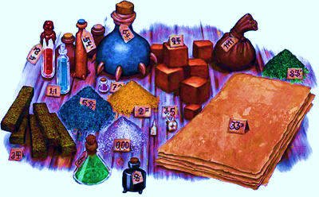

## Алхимия начинается в лесу[1]

Alchemists practice the arcane art of combining seemingly innocuous ingredients to produce substances with incredible properties. But where do these ingredients come from? A significant portion of what goes into an alchemist's labors can be found in the wilderness. Some of what is considered alchemy is sophisticated herb lore with an unusual twist. What the herbalist overlooks however, the alchemist treasures; for sometimes, when coupled with other reagents, even the most innocent weed can reveal astounding properties.

### Создание отвара

There are three steps to creating an herbalist concoction. First, you must gather the ingredients. Then, you must prepare and combine the ingredients to create the concoction. Finally, the concoction must be properly applied to take effect. Each of these steps is a distinct action. The details of each step is listed along with the concoction’s entry.

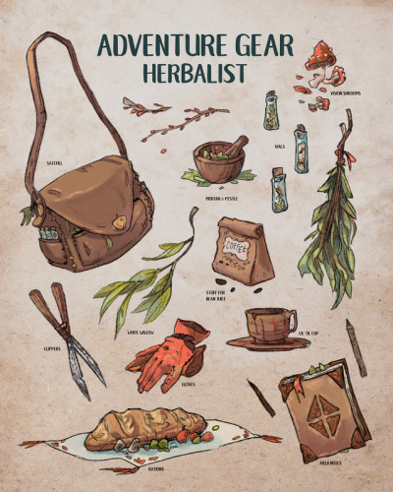

### Сбор ингридиентов

After you select the item you wish to craft, you must gather the ingredients for that item. You may only gather the ingredients for one item at a time. And you must be in the appropriate type of terrain specified by the recipe.

To gather the ingredients, you must spend one hour wandering the local area, searching for appropriate ingredients. During this time, you cannot perform any other tasks, nor can you travel too far in any specific direction and this period does not grant you the benefits for a short rest.

Alternatively, you can gather ingredients as a travel activity. This is similar to foraging except, instead of gathering food and water during a day of travel, you gather the ingredients required to craft an herbal item.

At the end of the gathering period, day of travel, or other period as specified by the GM, make a Wisdom check and add your proficiency bonus for your use of the herbalism kit. Compare the result to the DC required to craft the item you were trying to make. If your check result does not meet or exceed the DC required to craft the lowest quality version of the item, you failed to turn up enough useful ingredients. Otherwise, you turned up enough ingredients to produce the desired item at a highest quality whose DC to craft you met or exceeded.

EDIT: In general, gathered ingredients cannot be stockpiled with an herbalism kit. To properly gather and preserve ingredients for any significant length requires more extensive equipment, preservatives, sealed jars, and more careful gathering of herbs than a simple traveling kit allows. Most herbalists do keep stockpiles of carefully gathered ingredients on hand in their homes, shops, or labs to prepare herbal items for sale. A player who gathers ingredients with an herbalism kit must quickly turn them into the desired item or else they will spoil. Thus the act of gathering the ingredients and the act of crafting the item (see below) should be combined into one action.

A ranger with the natural explorer class feature may gather enough ingredients to produce two items of the same quality at the same time if they are in their favored terrain.

Finding herbs is a matter of both training and circumstance. Many herbs grow only in specific climates and conditions, and it takes a trained herbalist to locate such herbs with any reliability. Searching for ingredients takes one hour. This typically requires a Wisdom (Survival) check, though the specific check required and difficulty will be given along with each concoction. Collecting the specimen without damaging it requires an additional check, using the skill and DC listed. Once an ingredient has been harvested in a specific region, the DC to collect additional specimens increases by 5 for the next week. In high traffic areas, such as along a primary trade route or within a day of a town, the DC is permanently increased by 5. This effect is cumulative, making the harvesting of large quantities of rare herbs very difficult. Once picked, ingredients only remain fresh enough to use for a short amount of time. If an ingredient remains unused for more than one day, it loses potency and becomes worthless. A character proficient with an herbalism kit may spend one hour preserving the ingredients. This increases the amount of time the ingredient will remain fresh by 1d+6+1 days. 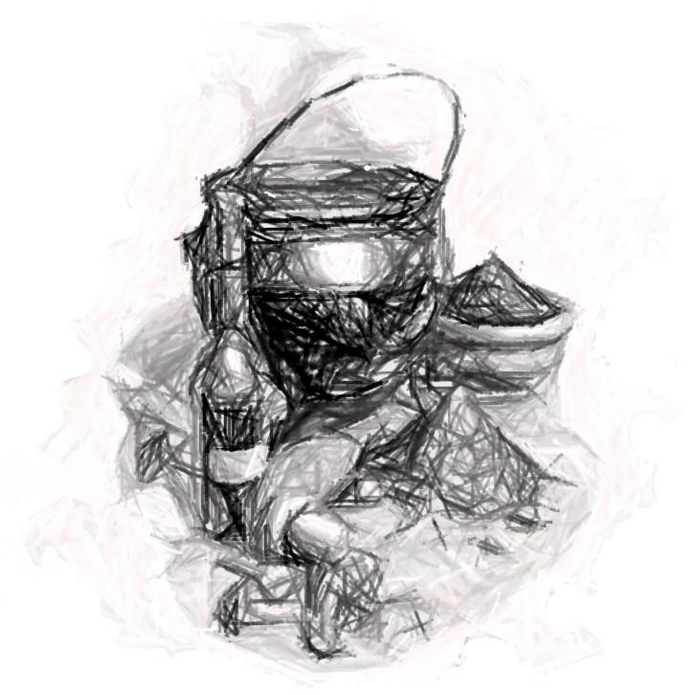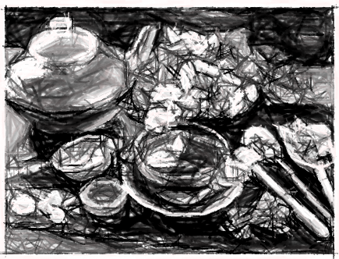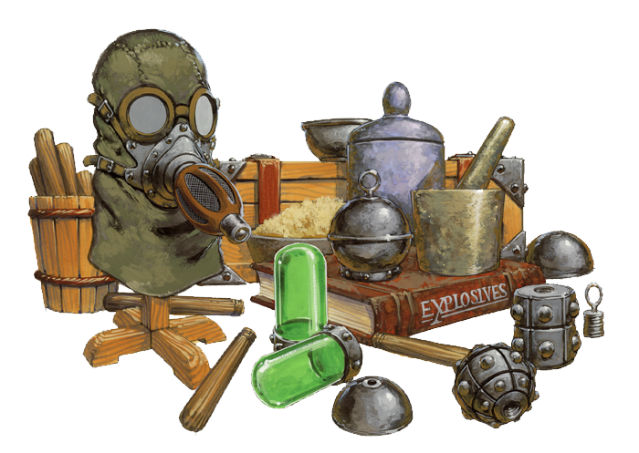

### Прочие ингридиенты

Some concoctions, particularly salves and powerful potions, may require ingredients that cannot simply be gathered from nature. These will be listed below the concoctions ingredient list, and will include information about their cost and rarity (if they can be purchased) or what type of creature they can be harvested from. If the ingredient can be harvested from a creature, the list will al, so include information about where that type of creature can be found, the creature’s DC, and the Wisdom (Survival) check required to locate the creature. As most creatures are not fond of donating their eyes, kidneys, or other organs to a party of strangers, harvesting the ingredient typically requires slaying the creature in question. Anyone proficient in Survival is able to harvest an organ from a deceased creature without damaging it, though the DM may require a Wisdom (Survival) check to harvest particularly fragile organs, such as eyes, heart, or brain, without damaging them beyond the point of being usable. Like other ingredients, those harvested from creatures quickly rot and spoil if unused. If they remain unused for more than one day, they begin ro rot and become worthless, though refrigeration or storage at cold temperatures extends this for an additional 1d4 days. A character proficient in Nature or alchemist’s kits may spend one hour preserving the organs. They may make a DC 10 Wisdom check to increase the amount of time the ingredient will remain fresh by 1d4 days. Preparing and Combining Ingredients The actual process of preparing and combining ingredients varies widely by concoction. Some salves can be created fairly quickly, by simply mashing the ingredients together with a mortal and pestle, while potions and infused oils may require hours of boiling to get the required purity. Each concoction will include a list of processes, as well as time and the DC for the skill checks, required to successfully complete the step. A failed check may be attempted again. However, if at any point the check fails by more than 5, the ingredients used in that process are ruined and you must begin that particular process again from the beginning. Once crafted, a concoction remains potent until used.

char-portraits:
“ Pei Zin Herbalist by ALRadeck
”

## Виды травяных смесей

### Зелья

Способ применения – внутренний.

### Мази

Способ применения - внешний

### Чаи и отвары

Способ применения – внутренний.

Способ приготовления – кипячение ингридиентов.

### Припарки

Способ применения – внешний.

## Вариантные правила по использованию зелий лечения

Эти правила предназначены изменить сценариий использования зелий лечения на высоких уровнях и сохранить ценность более дешевых зелий и для высокоуровневых персонажей.

### Зелье лечения (вариант)

Необычное, расходуемое, 50 зм, ½ ф

Красноватая жидкость в прозрачной колбе. Зелье лечения можно выпить действием, если оно находилось в рюкзаке или другом подобном месте, или бонусным действием если оно было закреплено в пределах быстрой досягаемости (например, на перевязи на теле. Выпитое зелье лечения восстанавливает 2к4+2 хитов и позволяет персонажу потратить свои кости хитов для восстановления хитов, при этом целебный эффект зелья увеличивает и эффективность костей хитов -каждая потраченная кость хитов на восстановление дополнительно восстанавливает 2 хита.

К сожалению, тонизирующий эффект зелья не позволяет использовать более одного зелья без совершения отдыха, но более мощные лечебные зелья все еще будут продолжать действовать.

### Зелье большого лечения (вариант)

Редкое, расходуемое, 200 зм, ½ ф

Красная жидкость в прозрачной колбе. Усиленная версия обычного зелья лечения за счет использования более редких трав и ингредиентов. Зелье большого лечения можно выпить действием, если оно находилось в рюкзаке или другом подобном месте, или бонусным действием если оно было закреплено в пределах быстрой досягаемости (например, на перевязи на теле. Выпитое зелье лечения восстанавливает 4к4+4 хитов и позволяет персонажу потратить свои кости хитов для восстановления хитов, при этом целебный эффект зелья увеличивает и эффективность костей хитов -каждая потраченная кость хитов на восстановление дополнительно восстанавливает 3 хита.

К сожалению, тонизирующий эффект зелья не позволяет использовать более одного зелья без совершения отдыха, но более мощные лечебные зелья все еще будут продолжать действовать.

### Зелье великого лечения (вариант)

Очень Редкое, расходуемое, 1000 зм, ½ ф

Алая жидкость в прозрачной колбе. Еще более усиленная версия зелья лечения за счет использования намного более редких трав и ингредиентов. Зелье великого лечения можно выпить действием, если оно находилось в рюкзаке или другом подобном месте, или бонусным действием если оно было закреплено в пределах быстрой досягаемости (например, на перевязи на теле. Выпитое зелье лечения восстанавливает 8к4+8 хитов и позволяет персонажу потратить свои кости хитов для восстановления хитов, при этом целебный эффект зелья увеличивает и эффективность костей хитов -каждая потраченная кость хитов на восстановление дополнительно восстанавливает 4 хита.

К сожалению, тонизирующий эффект зелья не позволяет использовать более одного зелья без совершения отдыха, но более мощные лечебные зелья все еще будут продолжать действовать.

### Зелье максимального лечения (вариант)

Легендарное, расходуемое, 5000 зм, ½ ф

Кроваво-алая жидкость в прозрачной колбе. Еще более усиленная версия зелья лечения за счет использования намного более редких трав и ингредиентов. Зелье максимального лечения можно выпить действием, если оно находилось в рюкзаке или другом подобном месте, или бонусным действием если оно было закреплено в пределах быстрой досягаемости (например, на перевязи на теле. Выпитое зелье лечения восстанавливает 10к4+20 хитов и позволяет персонажу потратить свои кости хитов для восстановления хитов, при этом целебный эффект зелья увеличивает и эффективность костей хитов -каждая потраченная кость хитов на восстановление дополнительно восстанавливает 5 хитов.

К сожалению, тонизирующий эффект зелья не позволяет использовать более одного зелья без совершения отдыха, а более мощных лечебных зелий пока еще не придумали.

## Применение отваров

The application of concoctions varies widely depending on the specific type. Some concoctions require nothing more than an action or bonus action to use. Others require more time and may also call for a specific skill check to receive the concoction’s full effect. Once a concoction has been applied, the effects may be immediate or gradual. The effect of a concoction will be described in the concoction’s entry.

## Арканическое Садоводство

A relaxing pastime for many, gardening remains a common pursuit among mages and alchemists, who often require specific plants and herbs for their crafts and experiments. It is little wonder, then, that arcane spellcasters of many stripes marry their profession with their pastime and create plants imbued with magical properties. The small sampling of species here just scratches the surface of the wonder to be found in the greenhouses and fields of the arcane gardener. 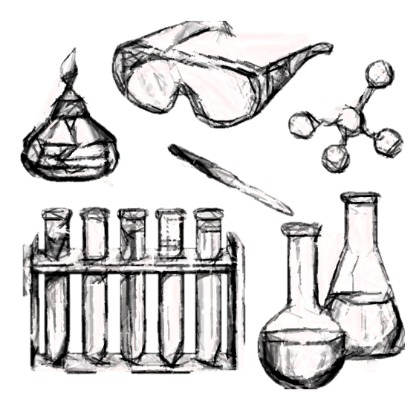

## Медицинские растения Дикого Фронтира

A number of plants in Savage Frontier can cure diseases, mend wounds, or even protect against foes.

The Wilderness Survival Guide provides detailed rules for this proficiency and the finding of medicinal plants.

The table that follows lists useful herbs found in the North. Herbs lose their potency quickly. Unless properly preserved, one point of potency will be lost each successive day after they are gathered.

**Herbalism Kit**. This tools proficiency, often learned by rangers, wizards, shamans and alchemists, allows the character to perserve medicinal herbs and to be able to make medicines (not potions) from fresh or preserved herbs which allow others not skilled in in herbalism kit or Nature to use the healing or curative effects of medicinal plants. Alchemists in the larger towns (such as Amelior Amanitas of Secomber), will be well versed in the craft. They can work wonders with combinations of sorcery and craftsmanship.

|  |  |  |  |
| --- | --- | --- | --- |
| d10 | Plant Name | Appearance Effective as | Method of Application |
| 1-2 | Beorunna’s cure | all stems special, see below *[2] | Boiled in tea |
| 3 | Feverbalm flowers | Cure insanity temporarily (1d10 hours) | Boiled in tea |
| 4 | Ghostroot pasty root | Repels undead as a 6th level cleric for 1d3 turns | Eaten raw |
| 5 | Mother’sleaf leaves | Cure disease (30% chance against any disease) | Boiled in tea |
| 6 | Spellshield berries | Gives imbiber a +1 saving throw against spells | Eaten raw |
| 7-8 | Trueroot red roots | Poison antidote (40% chance against any poison) | Eaten cooked |
| 9-10 | Woundwort small plant | Cures wounds of 1d4 points of damage | Poultice * |

andrea-the-great:
“ The Mage’s Lab by FrancescaBaerald
”
This is a great image for an NPC or a player character



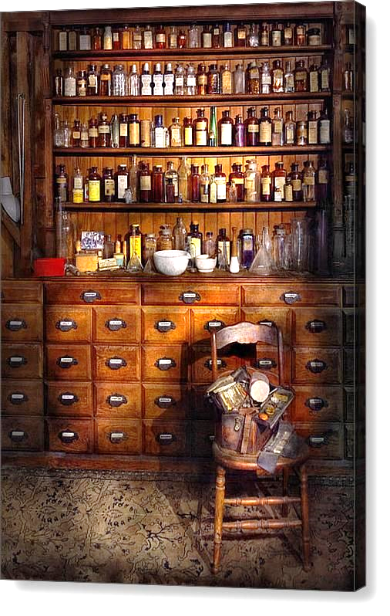

### Бытовая алхимия

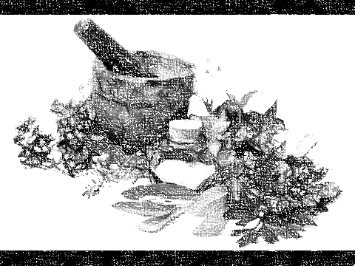

These items, while less potent and flashy than other alchemical substances, comprise a good portion of an alchemist's trade.

In most cases, these items provide relatively minor effects or speed mundane tasks for little cost. Many alchemists keep minor items such as these in stock, making more powerful or expensive items only on order.

ФОРМАТ ОПИСАНИЯ ТРАВЯНЫХ СМЕСЕЙ

Название

Тип смеси | Способ употребления | Сложность изготовления | Редкость – по шкале от Обычный до Мифический | Стоимость – в зм | Вес – в фунтах, если есть

------

УС изготовления: определяется сложностью| Редкость рецепта: от обыденного до мифического

Требуемые инструменты: набор травника и прочие необходимые для изготовления

Типовые ингридиенты: из чего как правило изготавливается смесь, один или несколько наиболее значимых ингридиентов

------

Описание смеси – внешний вид, запах, цвет. (Описание способа изготовления – как настаивается или каким образом обрабатываются ингридиенты)

Игромеханическое описание – описание действия смеси

### Titan Gum

Herbal |

Darkroot is used in great quantities by alchemists in the production of titan gum, a particularly strong and fast-setting form of glue. Titan gum bonds completely in one round. Substances bonded by titan gum require a DC 20 Strength check to separate. Titan gum can support 500 lbs. of weight before breaking.

DC of creation: 15.

Ingredients: Darkroot

### Journeyman Serum

Herbal |

Alchemy DC to Create: 5.

Ingredients: Wolfweed

Wolfweed has one function that is not commonly known. With careful preparation, it forms an integral part of an alchemical substance called journeyman serum. Journeyman serum provides a +2 bonus to Constitution checks made to resist taking subdual damage from making a forced march.

### Goblin Ink

Alchemy DC to Create: 10.

Ingredients: goblin rouge berry

The juice of the goblin rouge berry can be used in the creation of a high-quality waterproof ink, sometimes called goblin ink after its origin. The waterproof goblin ink cannot be smeared or distorted by water after it dries. It is popular for public notices and is sometimes used in spellbooks or other works that will be exposed to the elements.

### Shinewater

Herbal |

Alchemy DC to Create: 5.

Ingredients: halfling thistle

The heads of halfling thistles are used to create shinewater, a rust remover and polisher. Metal objects left in a bath of shinewater overnight shed all rust and corrosion, and they look highly polished after being dried and rubbed lightly with a soft cloth. One dose of shinewater is sufficient to de-rust one Medium-size metal weapon or a similarly sized object, and each bath is good for only one use.

### Lantern Stars

Herbal |

Alchemy DC to Create: 10.

Ingredients: cave star

Cave star does not shed sufficient light for good vision on its own. However, when placed in fist-sized glass globes and soaked with other reagents, the lichen sheds light equal to a torch for a time, after which it burns out. These lanterns, called lantern stars, last for 4 hours before burning out. They do not give off heat or smoke, and the light is constant and unwavering. The lanterns are often used in areas where the fire from torches might light pockets of gas or where flickering light is insufficient.

### Mother’sleaf leaves tea

### Feverbalm flowers tea

### Burnsoothe Ointment

Herbal |

Craft DC: 10/15/20

This paste, composed primarily of roots and plant oils, reduces pain and speeds the recovery of burns. If applied to a creature’s wounds within 10 minutes of their taking fire damage from any source or if applied within 10 minutes of the end of an encounter during which they took fire damage from any source, the creature heals 3 (1d6), 5 (1d6+2), or 6 (1d8+2) hit points depending on the quality.

Cost: Minor 20 gp; Moderate 40 gp; Masterwork 50 gp

Expires: 24 hours

Gather Ingredients: Forest, Swamp

### Venomcleanse Tea

Herbal |

Cost: Minor 15 gp; Moderate 30 gp; Masterwork 45 gp

Expires: 24 hours

Craft DC: 10/15/20

Gather Ingredients: Forest, Grasslands

This herbal tea composed helps cleanse the body of normal toxins. It is normally imbibed but can also be used to clean a poisoned wound. When a creature suffering from the poisoned condition is treated with this remedy, they may roll a new saving throw to end the poisoned condition immediately with Disadvantage, normally, or with Advantage depending on the quality of the tea.

### Woundbind Poultice

Herbal |

Ingridients:

Cost: Minor 20 gp; Moderate 40 gp; Masterwork 50 gp

Expires: 24 hours

Craft DC: 10/15/20

Gather Ingredients: Forest, Grasslands

This is a spongy mass of absorbent moss treated with a number of herbs designed to staunch bleeding, cleanse wounds, and dull pain. If bound over a wound, it promotes quick healing. When applied to a wound, the recipient heals 2 (1d4), 4 (1d4+2), or 5 (1d6+2) hit points depending on the quality.

### Woundwort small plant

Herbal | Poultice

Applying a salve made from woundwort allows a character to immediately regain 1d4+1 hit points.

Ingridients: woundwort small plant

### Herb 2

Herbal |

Ingridients:

Drinking a herb 2 potion gives a character advantage on all saving throws against Corruption for 1 week.

### Herb 3

Herbal |

Ingridients:

Wearing a necklace or bracelet of freshly woven herb 3 makes a character lucky for a 1d4 + 1 days. Whenever a lucky character rolls a 1 on a d20 for an attack roll, ability check, or saving throw, you can re-roll the die and must use the new roll.

### Herb 4

Herbal |

Ingridients:

ОТНОСИТЕЛЬНАЯ РЕДКОСТЬ, ОТНОСИТЕЛЬНАЯ СИЛА, ГДЕ ВСТРЕЧАЕТСЯ, КАКОЙ НАВЫК ВЛАДЕНИЯ ИНСТРУМЕНТОМ ПРИМЕНЯЕТСЯ ДЛЯ СБОРА ИНГРИДИЕНТА

Applying herb 4 salve to wounds allows a character to immediately recover 2 Hit Dice.

### Herb 5

Herbal |

Ingridients:

A character who drinks a herb 5 potion gains advantage on saving throws against poison for 1 hour.

Herbal |

### Herb 6

Herbal |

Ingridients:

A character who drinks a potion made from white herb 6 automatically gets the full Hit Die value of any Hit Dice spent to regain hit points during their next short rest.

### Herb 7

A character who drinks a potion made from herb 7 adds +2 damage to all melee weapon attacks made for the next hour.

### Gyumin Paste

Herbal |

Ingridients: Gyumin Beans

### Spellbane

Herbal |

Ingridients: Spellbane

### Spellslayer wine

Herbal |

Ingridients: Vaundyr Vine

### Felsul Flower Oil

Herbal |

Ingridients: Felsul

The felsul tree seems to favor cold and poor soil, and in many rocky places felsuls provide the only tree cover to be seen. Felsuls grow on crags, cliff edges, and clefts where few other trees can find purchase. They are gnarled, twisted trees whose wood crumbles to the touch and is of a dusty cinnamon brown to deep brown hue. When the trees flower in early spring (and not all trees flower every year), the crushed petals can be made into a fragrant perfume that adds a +1[3] bonus on any Charisma- checks made to persuade another (such as Deception, Persuassion, or Intimidate) for 10 minutes. A single ounce of the oil provides 10 uses, and a typical tree provides 1d4-1 (minimum 0) ounces of perfume per year.

### Shadowtop Torch

Herbal |

Ingridients: Shadowtop

The wood of the shadowtop tree burns more slowly (and cleanly) than normal wood. A torch of shadowtop wood burns for 2 hours and gives off very little smoke.

### Redroot Paste

Contact

Value: 30 gold per dose

Grinding the root into powder and mixing with water creates a paste which can be applied to wounds, healing an additional 1d4 hit points during a short rest. However, the paste also creates an interesting side effect of a slight numbness for 1d2 hours on the affected area. Injesting the paste is not recommended, as it causes nausea and vomiting unless a DC 15 Constitution save is made.

### Silverbark Sap

Herbal |

Ingridients: Silverbark

The sap of the silverbark tree is clear and slightly sticky. It acts as a (minor) natural antitoxin, granting anyone who consumes at least one ounce a +2 bonus[4] on Constitution saving throws against poison for 1 hour. A typical silverbark tree can be harvested of 2d4 ounces of sap per year.

### Oloore Root[5]

Potion | 100 gp

Oloore Root began as a druidic ceremonial tool for vision quests and communion with nature, but has become sought after by high society for its psychedelic properties. Drinking of the tea brewed from the root leads to heavy hallucinations, and sometimes grants insight to the world around them.

The imbiber must make a Constitution saving throw (DC 14) or become poisoned for 1d4 hours. Upon a success, the imbiber gains advantage on any Wisdom ability checks for 1 hour. On a saving throw of 19 or 20, the imbiber gains supernatural distance seeing, as though they had cast a scrying spell. They may Concentrate on this for up to 1 minute.

### Tej[6]

Adventuring Gear | 5 lb.

Tej is an amber-colored, fermented drink made from honey. It's more common and popular in Chult than beer or ale. A mug of tej costs 4 cp in Port Nyanzaru or 6 cp in Fort Beluarian. A 1-gallon cask costs 2 sp in the city or 3 sp at the fort.

### Allathorne Tea

Value: 50 gold per dose

Brewing the dried berries of the Allathorne bush into a strong and bitter tea creates a drink that staves off the cold. Those that drink the tea are granted a +1 bonus on saving throws against the cold, or cold based damage, for the next hour.

### Angel Wine

Value: 50 gold per bottle

Distilled from the Angel's Cactus, and sold throughout the Realms, this wine has a fruity flavor with a slight hint of an unusual taste that seems to vary with the person tasting it. No two wine aficionados can agree on the exact flavor, which often leads to heated debates among wealthy connoisseurs.

Some are suspicious of the interesting flavor, hinting that the Thayan merchants might be tainting the product with something insidious.

### Dathlil Petals

Ingested

Value: 5 gold per ounce

The petals of the flower can be brewed into a tea, or eaten whole to help neutralize poison. Ingesting the flower grants a +1 bonus to any saving throw to negate the ongoing effects of poison, including removing the poisoned condition.

### Deva Tears

Ingested

Value: 30 gold per dose

Drinking the sap which is exuded by the flowers heals a 1d4+1 hit points. A person may gain the benefit of drinking Tears a single time per day, and any additional ingestion requires the drinker to make a Constitution save or fall unconscious for 2d4+1 hours. This save is a DC 5, and increases by 1 each time the drinker has imbibed Deva Tears over the course of a day.

### Felsul Perfume

Inhaled

Value: 100 gold pieces per bottle (5 doses)

Distilled from the petals of the many colored blooms of the Felsul tree, the spicy aroma of the perfume makes grown men giddy and aroused.

The perfume grants a +1 bonus on Charisma (Persuasion) skill checks against men.

### Hart's Crown Weapons

Value: 50 gold per weapon

When a piece of a Hart's Crown bush is used as a weapon against a fey creature, it deals 1d6 additional piercing damage. Treat any such weapons as daggers or shortswords, although they break on an attack roll of ‘1'.

### Innai

### Sight Beyond

Value: 250 gold per dose

Ingredients: Aadarna

Grinding the root of the Aadarna plant into a fine powder, and mixed with a concoction of other commonly found herbs, an alchemist is capable of creating an interesting potion.

For the next hour after drinking, the vision of the character shifts to the Astral Realm. They may perceive what happens from a position that corresponds to their location in the Material Realm. During that time, they are blind to everything that happens in the Material Realm, including combat.

### Mallow Tea

Ingested

Value: 50 gold per dose

Brewed from the flower petals of the Mallow plant, the tea is predominantly brewed to ward away evil spirits.

Those that drink the tea gain Advantage on any saving throw meant to resist mind control or possession until the next short rest.

### Jalap Poultice

Contact

Value: 50 gold per dose

The leaves of the Jalap vine, once ground, are used to make a poultice. Application of the poultice grants grants an additional saving throw against the effects of snake venom.

### Stonewort Paste

Contact

Value: 250 gold per dose

Grinding the Stonewort leaves into a powder and adding liquid to create a paste creates an interesting concoction. It can be applied to the flesh and grants a +1 bonus to Armor Class for 2d6 minutes. However, more than a single application per day of the paste inflicts a -1 penalty on Dexterity based skill and saving throw rolls when applied, as the skin begins to stiffen and become numb.

### Djinn Blossoms perfume

Magical | Herbal | perfume

In addition, the djinn blossom can be made into a perfume with a successful DC 20 Craft (alchemy) check. This perfume grants a +2 bonus on all Charisma-based skill checks. Both a plucked blossom and a dose of perfume last for 24 hours after application. A djinn blossom grows to its full size in roughly a year, after which time it requires even more careful tending and pruning, lest it shifts back to the Elemental Plane of Air. A gardener caring for a mature djinn blossom (or djinn fern) must continue to make a check every month, with two failures in a row resulting in the plant returning to the Elemental Plane of Air. Provided a djinn blossom is cared for properly it can live for centuries. A healthy mature djinn blossom sells for 3,000 gp (a djinn fern for 2,000 gp). A djinn blossom bulb sells for at least 10,000 gp and can produce 1d4+2 plants. A dose of djinn blossom perfume costs 400 gp.

Ингридиенты:

### Menga Leaves

| | CHULT

Ingridients:Menga Leaves

The dried leaves of a menga bush can be ground, dissolved in a liquid, heated, and ingested. A creature that ingests 1 ounce of menga leaves in this fashion regains 1 hit point. A creature that ingests more than 5 ounces of menga leaves in a 24-hour period gains no additional benefit and must succeed on a DC 11 Constitution saving throw or fall unconscious for 1 hour. The unconscious creature awakens if it takes at least 5 damage on one turn.

A healthy menga bush usually has 2d6 ounces of leaves. Once picked, the leaves require 1 day to dry out before they can confer any benefit.

### Dancing Monkey Fruit

Rare

Ingredients: Dancing Monkey Fruit

This rare magical fruit produces enough juice to fill a vial. Any humanoid that eats a dancing monkey fruit or drinks its juice must succeed on a DC 14 Constitution saving throw or begin a comic dance that lasts for 1 minute. Humanoids that can't be poisoned are immune to this magical effect.

The dancer must use all its movement to dance without leaving its space and has disadvantage on attack rolls and Dexterity saving throws, and other creatures have advantage on attack rolls against it. Each time it takes damage, the dancer can repeat the saving throw, ending the effect on itself on a success. When the dancing effect ends, the humanoid suffers the poisoned condition for 1 hour

### Ryath Root

CHULT

Ingridients: Ryath Root

This chalky orange root has fortifying powers when consumed fresh or in properly-preserved form.

Ingesting a ryath root gives you 2d4 temporary hit points. If you consume more than one ryath root in a 24-hour period, you must succeed on a DC 13 Constitution saving throw or suffer the poisoned condition for 1 hour.

Unprocessed ryath root has the same effect but retains its potency for only 10 days after being harvested.

### Sinda Berries

CHULT

Ingridients: Sinda Berries

Liquid concoctions of these dark brown berries have a bitter aftertaste.

Consuming one dose gives you advantage on saving throws against poison and disease for the next 24 hours.

Fresh sinda berries, plucked from the bush less than 24 hours prior, have the same effect without any preparation or treatment if at least 10 of the berries are consumed.

### Wildroot

CHULT

Ingridients: Wildroot

This pungent, curative liquid is made from the juices of a rare root.

The liquid must be introduced to the subject's bloodstream, poured on an open wound or injected with a sharp device or weapon of some sort. Once administered, the creature is alleviated of the poisoned condition.

### Wukka Nut

CHULT

Ingridients: Wukka Nut (Chult, jungle)

This fist-sized nut rattles when shaken.

Shaking the nut as an action or bonus action causes the shell to shed bright light in a 10-foot radius and dim light for an additional 10 feet. This light will fade after 1 minute, but the nut can be shaken again to reactivate it. If the shell is ever cracked, the special properties are lost.

Fresh wukka nuts have the same effect without any preparation or treatment if plucked from a wukka tree no more than 48 hours prior.

### Yahcha Beetle

Ingridients: A yahcha (pronounced YAH-chah) is a harmless, meaty beetle about the size of a human hand, which feeds on worms and maggots. It moves slowly (walking speed 10 feet) and is easy to catch. A creature with mad monkey fever that eats a raw or cooked yahcha can immediately make a saving throw with advantage against that disease

This substance is a curative creature component. The flesh of this fist-sized beetle, when eaten, allows the consuming creature to immediately attempt a new saving throw, with advantage, against the disease known as “mad monkey fever.”

### Wittlewort Brew

Wittlewort brew immediately grants creatures under the effects of Enchantment spells or effects another saving throw to resist those effects. If the Enchantment effect did not allow an initial saving throw, wittlewort brew has no effect.

Wittlewort

A very fine herb with gossamer-like green fronds, wittlewort has a rapid growth cycle. Partly because of this rapid growth, it can be found only during spring months in temperate, subtropical, and tropical areas. Careful groundskeepers use it liberally in castle gardens, where it is grown to keep away slugs and other pests. However, only alchemical treatment can distill the full potency of this little plant. Once it has been dried, treated, and powdered, the alchemist dissolves the wittlewort in hot water to complete the alchemical process.

### Purebalm

Cotsbalm sap is extracted and used as a base for a clear, syrupy substance called purebalm. When applied to the skin of someone who has been poisoned by an injury or contact poison, purebalm turns black as it absorbs the poison out of the victim's system. Purebalm only functions when administered between the initial and secondary onset of an injury or contact poison. If applied before the secondary onset of an appropriate poison, purebalm provides a +8 alchemical bonus to the Fortitude saving throw to resist the poison's secondary effects.

Cotsbalm

This fleshy-leafed plant, characterized by clusters of small yellow flowers, grows to a height of 1 foot. A hardy plant, it can be found throughout temperate and subtropical forests. Many hedge wizards and midwives use cotsbalm as a folk remedy when treating sick children. After crushing the flowers until they emit a sweet smell, the herbalist sprinkles them around the child's bed to draw out the illness. Priests and other skilled healers claim that this has no effect, but the practice persists in many communities.

### Burn Salve

The boiled leaves from this plant form an integral part of burn salve, an excellent remedy for even severe burns. As its name implies, burn salve mitigates some of the effects of fire damage, but only if it is applied within 2 rounds of the injury. If applied in time, the smooth white salve heals 1d6 points of damage, but it cannot heal damage that was not inflicted by fire.

Musk Muddle

A brown, dead-looking plant with wide leaves and an unpleasant aroma, musk muddle can be found in nearly any swamp or marsh. Musk muddle resembles the dock plant, a foul-smelling weed. Unlike many of the plants described here, musk muddle has no common use, making it shunned or exterminated by those familiar only with folk remedies.

### Frost Lotion

The silvery edges of tyrant's sword can be boiled and used to make a warm, porridge-like substance called frost lotion. The pleasant-smelling topical heals injuries caused by extreme cold. Frost lotion can mitigate some of the effects of cold damage, but only if it is applied within 2 rounds of the injury. If applied in time, the thick lotion heals 1d6 points of damage, but it cannot heal damage that was not inflicted by cold.

Tyrant's Sword

A coarse, broad-leafed grass with sharp edges, tyrant's sword grows to a height of about 2 feet, distinguished only by the silvery edges of its leaves. Although difficult to find, it grows sporadically in both temperate plains and tundra regions. Tyrant's sword (named for its appearance) grows slowly and has a difficult time competing with other plants for survival. Because of this, it is usually found away from other plants.

.

### Senses

An alchemist who knows the proper distillation techniques can create a powerful effect by refining normal prickly tea into a stronger, fouler-tasting substance known as senses. Senses sharpens the imbiber's eyes and ears, providing a +1 alchemical bonus to Spot and Listen checks for 1 hour.

Prickly Tea

A small thorn bush with gray-green leaves, prickly tea rarely grows over 3 feet in height. Although it is almost never found in large groups, the thorny bush can be found throughout temperate and subtropical plains and forests. Prickly tea is a staple in church and abbey gardens because its leaves can be gathered, dried, and boiled to make a bitter tea that helps awaken the drinker and sharpen her senses. Early risers, as well as high-priced sentries, often drink the tea to stay alert

### Vine Oil

Living sand vine can be cut and its juices squeezed out. When combined with more common ingredients, this juice forms a weak local anesthetic called vine oil. When spread on bare skin, vine oil numbs the area, allowing the user to withstand great amounts of pain. While the effects of vine oil last, the user can function normally until reduced below -5 hit points, but when reduced below 0 hit points, he still loses 1 hit point per round. If reduced below -5 hit points, the user falls unconscious. When the user's hit point total falls below -10, the user dies. Creatures who have used vine oil within the last 24 hours cannot stabilize on their own, and many warriors have died while using this oil, succumbing to their injuries before an ally could reach them to staunch their wounds. The effects of vine oil last for hour. Vine oil smells faintly of fish, and those who use it regularly can often be identified by its smell.

Sand Vine

A rope-like seaweed found in temperate or warmer coastal areas, sand vine resembles a long, inch-thick rope. The vine grows both above and below water level, and it commonly grows with its roots wrapped around a small rock. Sand vine is relatively rare and is found only in areas where the tides and waves are mild. Since sand vine retains its strength after being harvested and dried, small coastal communities often cultivate it and braid it into long, sturdy rope.

### Gash Glue

Old man's friend can be crushed and mixed with a number of other substances to produce a thick, gray glue called gash glue. Soldiers often carry gash glue to seal a fallen companion's wounds quickly. One application of gash glue stabilizes a dying creature.

Old Man's Friend

Old man's friend is a sticky-leafed herb that rarely grows above 2 inches in height. The herb can be found in huge beds (often 10 feet or more on a side) in temperate areas that get a lot of sunlight. Old man's friend is a strange herb that has an effect not unlike catnip except that it affects canines. Dog lovers have been known to cultivate small beds of this herb to keep their animals happy.

### Elf Hazel

The sap of the elven willow is the main component in a fluid called elf hazel. If elf hazel fluid is applied to any scar (from a now-healed wound) the scar slowly vanishes. It takes a week of daily applications for the scar to vanish completely.

Elven Willow

The elven willow is a small tree (maximum height 5 feet) that grows by the banks of rivers in temperate forests. The willow has a golden sheen to its bark and produces golden colored buds in the spring. There is much superstition concerning the elven willow. It is said that each elven willow bears the spirit of a love-loin elf who drowned in a river near the tree.

Health and Healing Substances

|  |  |  |
| --- | --- | --- |
|  |  |  |
| Item | Cost | Craft DC |
| Wittlewort Brew | 30 gp | 15 (alchemy) |
| Purebalm | 75 gp | 35 (alchemy) |
| Burn Salve | 15 gp | 10 (alchemy) |
| Frost Lotion | 15 gp | 10 (alchemy) |
| Senses | 50 gp | 25 (alchemy) |
| Vine Oil | 50 gp | 15 (alchemy) |
| Gash Glue | 40 gp | 20 (alchemy) |
| Elf Hazel | 5 gp | 10 (alchemy) |

## Poisons And Malefics

The following substances, while not dangerous on their own, mix well with poisons, making the poisons harder to resist or adding dangerous side effects. When adding one of these substances to a poison, a character without the poison use ability has a 5% chance of exposing himself to the poison, much like the exposure chance one risks when applying the poison to a weapon. When applying an enhanced poison to a weapon or otherwise readying it for use, the character risks exposure normally. If either exposure chance is failed, the poison is treated as if enhanced by the alchemical substance when it affects the user. Only one alchemical substance may be added to a dose of poison. The prices listed reflect the cost of enhancing one dose of poison.

### Oakdeath

The bark of the dwarven oak can be used to create a viscous brown liquid that can be added to any poison to increase its toxicity. Dealing in oakdeath is illegal in most places and often carries the same penalty as actually poisoning someone. If added to a poison less than 1 hour before the poison's application, oakdeath increases the poison's DC by 2.

Dwarven Oak

Dwarven oak is a stunted, gnarled affair with thick, iron-hard roots and heavily wrinkled bark that grows on the lower slopes of temperate mountains. From a distance, the tree looks somewhat like a sitting dwarf, and goblin arrows occasionally jut from lone trees. Aside from providing goblins with target practice, the tree has no common use.

### Night Venom

The root of the orticusp is pulped and mixed with a poison to make a potent additional effect. If the victim of a night-venom-enhanced poison fails the initial Fortitude save to resist the poison, she must immediately make an additional Fortitude save against the poison's normal DC. If the victim fails this save, she falls into a fitful slumber until the poison's secondary effect sets in. Creatures sleeping due to the effects of a night-venom-enhanced poison can be awakened by normal means.

Orticusp

The orticusp root bears a striking resemblance to a clenched fist. The root is pale white and is extremely difficult to find as the portion of it that is above ground only lives for about a week in the summer. Extremely rare, orticusp is found only in ancient temperate forests with trees more than 150 years old. The orticusp root gives off a pleasant, earthy aroma that only fey can smell. Fey within 20 yards of an orticusp root can seek it out easily. Legends say that before the dark elves left the surface realms, orticusp was a beautiful, night-blooming flower, beloved of that race. Supposedly, the flower took on its current form only after the sundering of the elven race.

### Mindfire

What is not commonly known is that the stem of the wild fireclover is capable of producing a powerful mind-clouding addition to a normal poison. When combined with an ingested poison, mindfire leaves the imbiber confused and disoriented. Imbibers who fail either save required by a mindfire-enhanced poison suffer a -2 alchemical penalty to Will saves. In addition, spellcasters affected by a mindfire-enhanced poison must make a Concentration check (DC 15 + spell level) to cast spells. The effects of mindfire last for one hour. Mindfire can only be combined with ingested poisons.

Wild Fireclover

Wild fireclover is a summer plant with a brilliant red and orange flower that blooms in temperate plains and farmland. The unmistakable red blooms of fireclover are usually found in small clusters of three to ten. The petals of wild fireclover are often crushed and used by peasants to provide pleasant scents. Crushed petals provide a beautiful aroma for up to a week.

### White Sanguine

Powdered meadow giant stem is the principle ingredient in white sanguine, a milky, viscous substance smeared on assassin's blades to prevent blood clotting. Wounds inflicted by a weapon covered in white-sanguine-enhanced poison often fail to clot. If the victim fails the initial Fortitude save to resist the enhanced poison's effects, the wound continues to bleed for one minute, inflicting 1 point of damage per round in blood loss. The bleeding can be stopped with a DC 15 Heal check or the application of any cure wounds spell. White sanguine can only be combined with injury poisons.

Meadow Giant

Meadow giant is a massive, green-stemmed weed. The plant is found in grassy meadows where solitary plants seem to spring up overnight. A versatile and tenacious plant, meadow giant can be found in temperate grassland, farmland, and plains. Meadow giant can easily threaten cultivated crops, so it is usually cut down in farming areas.

Poisons And Malefics

|  |  |  |
| --- | --- | --- |
|  |  |  |
| Item | Cost | Craft DC |
| Oakdeath | 100 gp | 25 (alchemy) |
| Night Venom | 500 gp | 30 (alchemy) |
| Mindfire | 200 gp | 30 (alchemy) |
| White Sanguine | 100 gp | 20 (alchemy) |

### Nightlight (vial)

Ingredients:

UNDERDARK

A dose of this dark liquid is typically prepared in a thick glass vial.

The substance is activated by shaking it vigorously as an action or bonus action. Thereafter, the substance emits light for a period of one round, then goes out for a round, then emits light for a round, continuing this strobing pattern until it has emitted 1d6+2 total rounds of light. The interval of light and darkness switches at the start of your turn each round. When lit, the nightlight produces bright light in a 30-foot radius and dim light for an additional 30 feet.

Nightlight is made from a tall, tubular bioluminescent mushroom of the same name that grows in the Underdark. A living nightlight emits bright light in a 15-foot radius and dim light for an additional 15 feet. If a living nightlight is touched, either by a creature or object, its light goes out until it is touched again.

### Nillhog’s Nose

UNDERDARK

Ingredients:

This small mushroom heightens the consumer’s sense of smell.

Consuming one dose grants you advantage on Wisdom (Perception) checks based on smell for 1d4 hours. During this period, you suffer disadvantage on saving throws against harmful effects based on smell, like a troglodyte's poisonous stench.

One fresh Nillhog's nose mushroom has the same effect if used within 48 hours of being picked.

### Ormu Paint

UNDERDARK

Ingridients:

This green phosphorescent paint is crafted from bioluminescent moss harvested in the Underdark.

Ormu paint sheds dim light in a 5-foot radius for 24 hours after it is applied. This large jug holds one gallon of paint.

### Sunberry Wine

Ingested

Value: 50 gold per bottle

Brewing the sunberries, and letting it age for a few years, a few vintners in Cormyr create a tasteful wine that is in limited supply. The golden wine is quite tart, and highly sought after in Waterdeep.

### Tongue of Madness

UNDERDARK

Ingridients:

This concoction has a delightfully-earthy scent and is designed to be administered orally.

Drinking this requires you to make a DC 12 Constitution saving throw or compulsively speak aloud your every thought for the next hour. The effect can be ended with a lesser restoration spell or similar magic.

Unprocessed tongue of madness is an edible fungus that looks like a large human tongue. It has the same effect if used within 72 hours of being picked.

### Torchstalk

UNDERDARK

Ingredients:

A torchstalk is a mass of thin fungal fronds, about the size of a torch, bound together around a flint striker.

The device can be thrown as an improvised missile weapon, targeting a foe up to 20 feet away as an action. On impact, or if lit, the torchstalk bursts in a cloud of fiery spores. Creatures within 10 feet of the target (or the square where it lands in the case of a miss) take 1d6 fire damage.

Unprocessed torch stalks have a 1-in-6 chance to explode when lit. The head of an unexploding frond otherwise burns like a torch, lasting up to 24 hours.

## Ranger concotions

Для использования с вариантом рейнджера от Киборгов и Чародеев.

### ACIDIC FLASK[7]

BREW

As an action, you can hurl this Concoction at a creature or object within 30 feet of you. The Flask shatters on impact. A creature that fails a Dexterity saving throw takes 2d6 + your Wisdom modifier of acid damage. An inanimate object is automatically hit, and the damage is maximized.

At higher levels.

Your Acidic Flask deals an additional 2d6 acid damage at 5th, 9th, 13th, and 17th levels.

Source:

### Betterberry Gruel[8]

Brew

A creature can spend an action to consume this gruel. It provides enough nourishment to sustain a creature for 24 hours and grants that creature 1 temporary hit point for each Ranger level you have. Once consumed, a creature needs a long rest before they are able to gain these benefits again.

At higher levels. The Gruel hold an additional serving at 5th, 9th, 13th, and 17th levels.

### Bloodfire Poison[9]

Brew

This Concoction can be used to poison a slashing or piercing melee weapon or set of ammunition. As a bonus action, you can coat a blade or piece of ammunition with the poison. Your next successful weapon attack that uses the poisoned blade or ammunition deals an additional 1d4 poison damage. Poisoned ammunition that misses can potentially be reclaimed, at the DM's discretion. There are enough servings of the poison for two applications to be made in this way. Poison that's been applied to a weapon or piece of ammunition lasts for up to an hour if unused in a successful attack.

Food or drink that has been poisoned with this Concoction carries a slightly metallic flavor that can be detected with a successful Intelligence (Investigation) check or with a high enough Passive Perception contested by your Concoction DC. Creatures that ingest the poison take the maximum amount of damage per serving used.

At higher levels. The poison's damage die increases to 1d6 at 5th level, 1d8 at 9th level, 1d10 at 13th level, and 1d12 at 17th level.

Source:

### Draught of Soft Steps

Brew

A creature can drink this slippery Concoction as an action to temporarily improve their fine motor control, granting it a +10 bonus to any Dexterity (Stealth) checks for the next hour.

At higher levels. At 5th level, you revise the recipe to produce a foul-smelling vapor that, when breathed in deeply, provides the same benefits as drinking the Draught would. As a bonus action, you can open the Concoction and expose the mixture to the air, creating an invisible cloud of vapor around you. Creatures of your choice that stay within 30 feet of you can continuously inhale the Concoction's vapor to add +10 to their Dexterity (Stealth) checks as well.

At 13th level, choosing to drink the Draught instead grants a +10 bonus to any Dexterity (Sleight of Hand) checks made as well.

Source: Brew, page 7

### Draught of the Beast

Brew

As an action, you can drink this Concoction and undergo a temporary hallucinogenic effect for ten minutes. You can interpret the sounds a beast makes as language, letting you hold basic conversations with them. The knowledge and awareness of many beasts is limited by their intelligence, but at minimum, beasts can give you information about nearby locations and monsters, including whatever they can perceive or have perceived over the last day.

At higher levels. At 5th level, you can share this Concoction with a willing beast to temporarily share its awareness. For the Concoction's duration you become blind and deaf, but perceive through the beast's senses instead, including any special ones that the beast may have. You may end the effects early using an action to regain your senses.

By 9th level, your survival senses become heightened and can make Wisdom (Perception and Survival) checks with advantage for the duration.

By 13th level, the Concoction's effects grant you a powerful primeval fighting instinct. For the duration, your fingertips harden into claws, allowing you to make unarmed melee attacks for the duration with which you are proficient. These attacks deal 1d6 slashing damage and use either your Strength or Dexterity modifier.

At 17th level, the unarmed damage increases to 1d8.

Source: Brew, page 8

### Firewater Flask

Brew

As an action, you can hurl this Concoction at a creature or point within 30 feet of you. The Flask shatters on impact and creates a 10-foot radius cloud of noxious vapor there for one minute before dissipating. Creatures inside this cloud at the start of their turn must make a Constitution saving throw. On a failed save, the creature's eyes begin to sting unbearably, causing any attacks it makes on that turn to be made with disadvantage. If a creature has Blindsight, Tremorsense, or has no eyes, they are unaffected by the cloud of vapor.

A moderate wind (of at least 10 miles per hour) disperses the cloud after 5 rounds. A strong wind (at least 20 miles per hour) disperses it after 1 round.

You can drink this to become drunk, although it isn't a pleasant way to do so.

At higher levels. By 9th level, you've learned how to make this Concoction flammable. If the cloud is set alight by either magical or nonmagical means, the cloud is ignited into a ball of flame before immediately dissipating. Creatures caught in the flame must make a Dexterity saving throw. On a failed save, they take 8d6 fire damage, or half as much on a successful one.

Source: Brew, page 9

### Glimmeringbug Flask

Brew

As an action, you can hurl this Concoction at a creature or point within 30 feet of you. The Flask shatters on impact, sending countless glittering shards of dust into the air within a 10-foot radius sphere. Creatures within that sphere must make a Dexterity saving throw. If they fail, they are covered in the dust. Creatures coated in the fine dust seem to shimmer, making them easier to target. Attacks against creatures covered in this dust are made with advantage. The dust comes loose and falls away after one minute.

At higher levels. By 9th level you've learned how to polish the Glimmerbug fragments even further, forcing affected creatures to have disadvantage on Dexterity (Stealth) checks.

Source: Brew, page 8

### Glow Potion

Brew

You create a syrupy, luminescent mixture that emits bright light for 20 feet and dim light for another 20 feet. This Concoction contains enough liquid for three servings, with each serving powerful enough for it to glow for four hours. You can add a chemical reagent as a bonus action on your turn to change the color of the light or pause the glowing effect: saving the remaining time for later use.

As an action, you can apply one serving of this mixture to an item or willing creature to emit light from it. You can wipe the mixture off to snuff out the light as a bonus action. If you attempt to apply this mixture on an unwilling creature, it must make a Dexterity saving throw to avoid it.

At higher levels. By 9th level, you make the mixture acidic using toxic ingredients. By expending two servings as an action, you can dip a blade or arrow in the Concoction before immediately making a single weapon attack. If it hits, the target takes an additional 4d6 acid damage and emits a dim glow until the end of your next turn, granting the next ally to make an attack against it advantage on the attack.

At 13th level, the bonus damage increases to 5d6. At 17th level, it increases to 6d6.

Source: Brew, page 8

### Healing Draught

Brew

Drinking this Concoction regains health equal to 1d8 + your Wisdom modifier. A creature can benefit from these effects once per short rest. Creatures that drink additional Healing Draughts before taking a short rest are only healed for half as much. This Draught can be administered to another willing creature as an action.

At higher levels. This Draught heals for an additional 1d8 at 5th, 9th, 13th, and 17th levels.

Source: Brew, page 7

### Panacea Draught

Brew

A blinded, deafened, diseased, or poisoned creature that drinks this Concoction gains advantage on its saving throws for the next minute in order to recover from these conditions.

At higher levels. By 9th level, you've learned how to treat most temporary ailments. Your Panacea can immediately cure one of the statuses listed above in addition to its other benefits.

Source: Brew, page 8

### Sleep Flask

Brew

As an action, you can hurl this Concoction at a creature or point within 30 feet of you. The Flask shatters on impact, creating a 10-foot radius cloud of sleeping gas. Roll 3d8; the total is how many hit points of creatures this Concoction can affect. Creatures within 10 feet of a point you choose within range are affected in ascending order of their current hit points (ignoring unconscious creatures).

Starting with the creature that has the lowest current hit points, each creature affected by this cloud of sleeping gas falls unconscious for one minute. If the sleeper takes damage or someone uses an action to shake or slap the sleeper awake, the creature wakes back up. Subtract each creature's hit points from the total before moving on to the creature with the next lowest hit points. A creature's hit points must be equal to or less than the remaining total for that creature to be affected. Undead and creatures immune to being Charmed aren't affected by this Concoction.

This Concoction can be used to drug food and drink. When applying it in this way, roll the dice before any creatures ingest it. The order of creatures affected by it is determined by the order in which it is consumed.

At higher levels. Roll an additional 2d8 when determining total hit points of creatures affected at 5th, 9th, 13th, and 17th levels.

Source: Brew, page 9

### Tar Flask[10]

Brew

As an action, you can hurl this Concoction at a creature or point within 30 feet of you. The Flask shatters on impact and spreads the Tar in a 10-foot radius, turning it into difficult terrain. Targets within 5 feet of the Flask's point of impact must make a Dexterity saving throw. On a failed save, the creature is covered in the thick Tar and is 9 restrained for up to one minute. The creature can use its action every turn to make a Strength saving throw and extract itself from the Tar. The Tar dries quickly and loses its stickiness after one minute.

At higher levels. By 5th level, all creatures within the radius of the Tar must make a Dexterity saving throw when it's spread. At 9th level, you start mixing the Tar with flammable ingredients that can be set alight once spread. If set alight, creatures who enter or start their turns in the terrain take 2d6 fire damage. Once set on fire, the Tar burns away after 30 seconds or 5 rounds of combat. A creature covered in the Tar remains lit and takes fire damage until they extract themselves from the Tar or it burns away.

Source:

### Vial of Nurseweed

Brew

A creature can spend a bonus action to drink this small vial of foul-smelling liquid to regain 2d4+4 health. This Concoction dulls the nerves to provide some temporary pain relief, granting it temporary hit points equal to half your Ranger level (rounded up). A creature cannot benefit from this Concoction again until it finishes a long rest. This Vial can be administered to another willing creature as an action.

At higher levels. This Vial heals for an additional 1d4 at 5th, 9th, 13th, and 17th levels.

Source: Brew, page

Vial of Cat's Sight

Brew

A creature can drink this Concoction as a bonus action and dilate their eyes beyond their normal limits for an hour, either granting them darkvision of 30 feet or increasing their existing darkvision by 15.

At higher levels. The effects are extended by an additional hour and can hold an additional serving at 5th, 9th, 13th, and 17th levels.

Source: Brew, page 7

Vial of Everlasting Air

Brew

Drinking this Concoction as a bonus action boosts the drinker's lung capacity, tripling the duration a creature can hold its breath for. This Concoction's effects last for one hour.

At higher levels. This Concoction becomes further concentrated to hold one extra serving per Vial for each time you reach 5th, 9th, 13th, and 17th levels. At 9th level, the Concoction's potency is also increased, letting creatures who drink this hold their breath for up to five times their normal duration.

Source: Brew, page 8

## Ссылки

<https://theangrygm.com/crafting-herbcraft-part-1/>

[Herbalism:Defined, Refined, and Usable](https://www.dmsguild.com/product/180321/HerbalismDefined-Refined-and-Usable?term=herbalism)

[Homebrewed Crafting - Herbalism](https://www.dmsguild.com/product/216525/Homebrewed-Crafting--Herbalism?affiliate_id=759617)

[Herbalism 101](https://www.dmsguild.com/product/290930/Herbalism-101?affiliate_id=759617)

Potioneering Defined Refined and Usable

Herbalism & Alchemy

Damion Meany - Improved Crafting Herbalism

[ТРАВЫ ЗАБЫТЫХ КОРОЛЕВСТВ](https://1drv.ms/w/s!Atcrhwwo1lBAxu8P2h0tAiM-mtPXeA?e=HjD2ji)

1. by Kieran Turley with Jess Decker, Dragon #301
2. Beorunna’s cure-all This plant is a general restorative. It gives a +10 bonus for curing all diseases, or +2 bonus for healing hit points. It can be used in addition to any of the other curative herbs or spells, supplementing the effects of those herbs or magic. However, it is only a supplement. On its own, it cannot cure any
3. competence
4. alchemical
5. TDCS, page 55
6. ToA, page 32
7. Brew, page 7
8. Brew, page 9
9. Brew, page 8
10. Brew, page 8